**Example: Crew Scheduling**

**Set up the Crew Scheduling model in Excel:**

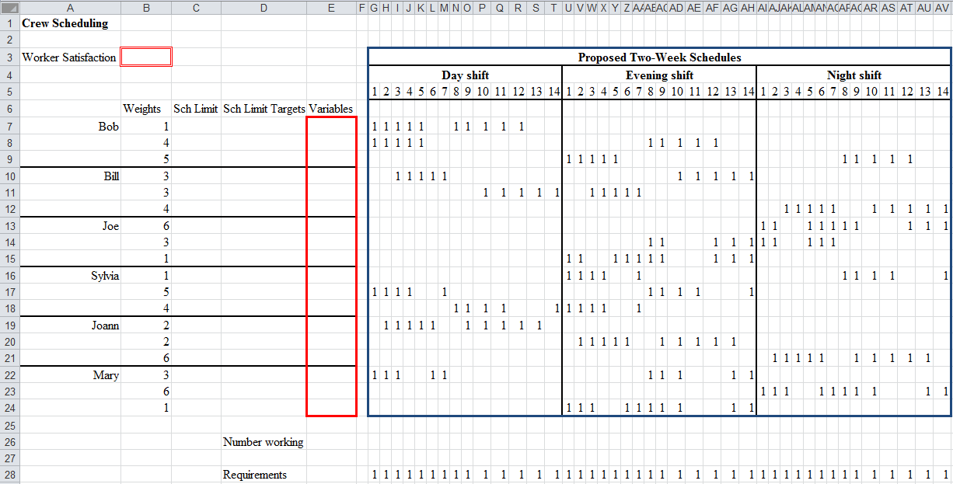

**Example: Crew Scheduling**

**Solver Solution:**

